COA ASSIGNMENT No. 4
Aaditya Yuvaraj Hande
Div/Batch: A/A1
Roll No: 17
PRN: 202401040028

Topic: BCD to HEX and vice versa

Result:
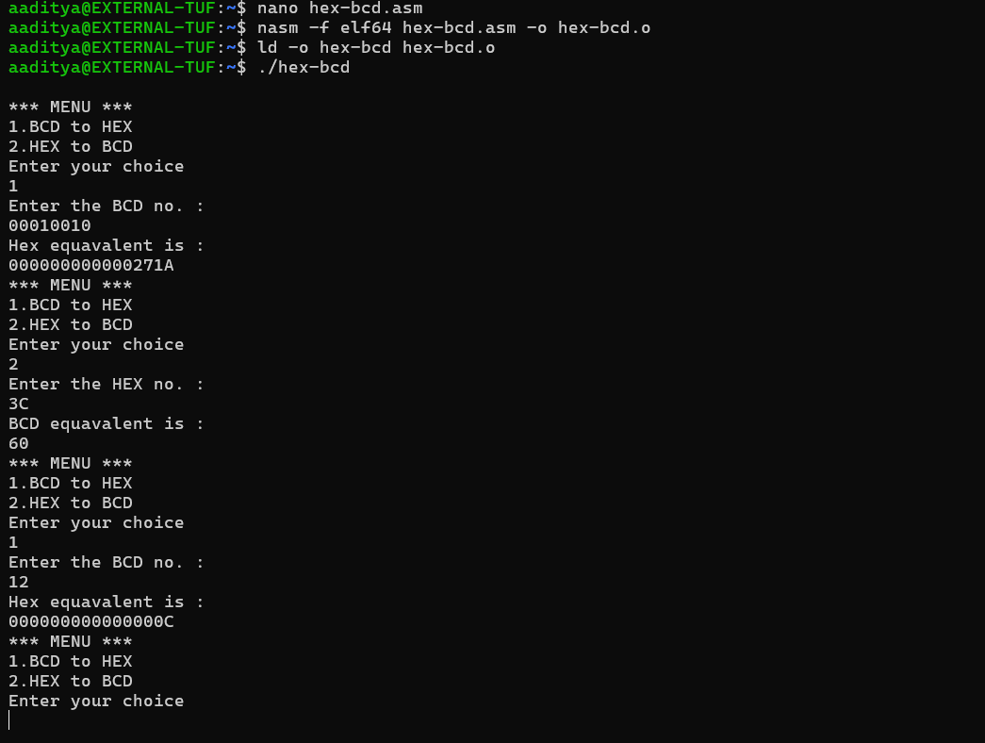
Code:
%macro WRITE 02
mov rax ,1
mov rdi ,1
mov rsi ,%1
mov rdx ,%2
syscall
%endmacro

%macro READ 02
mov rax ,0
mov rdi ,0
mov rsi ,%1
mov rdx ,%2
syscall
%endmacro

section .data
msg1 db "Enter the BCD no. : ",10
len1 equ $-msg1
msg2 db "Hex equavalent is : ",10
len2 equ $-msg2
msg3 db "Enter the HEX no. : ",10
len3 equ $-msg3
msg4 db "BCD equavalent is : ",10
len4 equ $-msg4
msg5 db "Wrong choice",10
len5 equ $-msg5
menu db 10,"*** MENU ***",10
db"1.BCD to HEX",10
db"2.HEX to BCD",10
db"Enter your choice",10
menulen equ $-menu

section .bss
char_buff resb 17
ans resq 1
cnt resq 01
char resb 01
choice resb 02

section .text
global _start

_start:
printmenu : WRITE menu,menulen
READ choice,02
cmp byte[choice],31H
je BCDtoHEX
cmp byte[choice],32H
je HEXtoBCD
cmp byte[choice],33H
je exit
WRITE msg5,len5
jmp printmenu

mov rax,60
mov rdx,00
syscall

BCDtoHEX:
WRITE msg1,len1
READ char_buff,17
dec rax
mov rcx,rax
mov rsi,char_buff
mov rbx,00H
up: mov rax,0AH
mul rbx
mov rbx,rax
mov rdx,00H
mov dl,byte[rsi]
sub dl,30H
add rbx,rdx
inc rsi
dec rcx
jnz up

mov[ans],rbx
WRITE msg2,len2
mov rbx,[ans]
call display
jmp _start

HEXtoBCD:
WRITE msg3,len3
READ char_buff,17
call accept

mov byte[cnt],00H
mov rax,rbx
up1:mov rdx,00H
mov rbx,0AH
div rbx
push rdx
inc byte[cnt]
cmp rax,00H
jne up1

WRITE msg4,len4

up2:pop rdx
add dl,30H
mov byte[char],dl
WRITE char,01
dec byte[cnt]
jnz up2
jmp _start

exit : mov rax,60
mov rdi,00
syscall
ret

accept: dec rax
mov rcx,rax
mov rsi,char_buff
mov rbx,00H

up4:shl rbx,04H
mov rdx,00H
mov dl,byte[rsi]
cmp dl,39H
jbe l1
sub dl,07H
l1:sub dl,30H
add rbx,rdx
inc rsi
dec rcx
jnz up4
ret

display: mov rcx,16
mov rsi,char_buff

up3:rol rbx,04H
mov dl,bl
and dl,0FH
cmp dl,09H
jbe l2
add dl,07H
l2:add dl,30H
mov byte[rsi],dl
inc rsi
dec rcx
jnz up3
WRITE char_buff,16
ret

